**Department of Electrical Engineering and   
Computer Science**

**Faculty Member:** Dr. Arbab Latif  **Dated:** 04/04/2022

**Semester:** 4th **Section:** BEE 12C

**EE-222: Microprocessor Systems**

Lab 8: AVR Serial Communication

Group Members

|  |  |  |  |  |
| --- | --- | --- | --- | --- |
| **Name** | **Reg. No** | **Report**  **Marks / 10** | **Viva**  **Marks / 5** | **Total**  **Marks / 15** |
| Danial Ahmad | 331388 |  |  |  |
| Muhammad Umer | 345834 |  |  |  |
|  |  |  |  |  |
|  |  |  |  |  |

# Experiment

## Objectives

1. Setup ATmega16A microcontroller for UART communication.
2. Send and receive serial data from ATmega16A.
3. Setup serial link between your PC and ATmega16A microcontroller through UART interface.

## Introduction

 Atmel Studio IDE is a free development environment for programming Atmel MCUs, sourced by Microchip Technology Inc. It provides us with the means to simulate assembly language codes on specific Microcontrollers and provides an easy and intuitive way of producing .HEX files, which are what makes burning the code on the hardware possible.

In this specific lab, we familiarize ourselves with serial communication in ATmega16A using Universal Asynchronous Receiver Transmitter (UART). We implement simple and straightforward tasks to observe the Transmission and Receiving action of TXD and RXD on a serial monitor, respectively. Lastly, we implement our previous knowledge of interrupts to create a up-down counter binded to specific keyboard keys and also remains unaffected when any other key is pressed.

## Flowchart

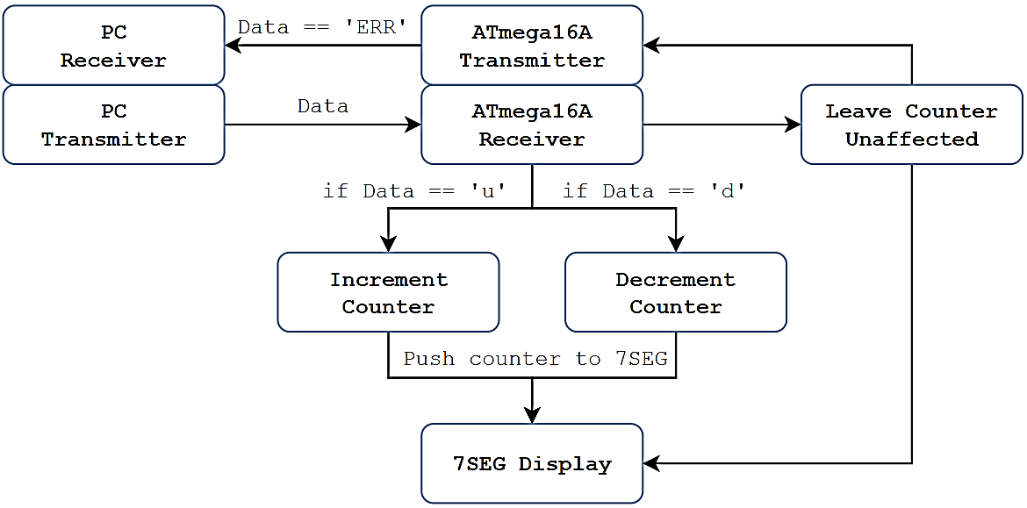

# Lab Tasks

## Task A

Estabilish connection between your ATmega16 and PC through UART-to-TTL converter. Run the programs in section 3.3 and 3.4 and explain your observations through screenshots.

## 3.3:

**#define *F_CPU* 1000000**

**#include <avr/io.h>**

**#include <util/delay.h>**

**//function to initialize UART communication**

**void UART_initializer(){**

**UBRRL = 0x0C ; //set baud rate to 4800**

**UCSRB |= (1<<TXEN) ; //enable transmitter**

**UCSRC |= (1<<URSEL)|(1<<UCSZ0)|(1<<UCSZ1) ; //set data size**

**}**

**//function to transmit data over UART**

**void UART_transmitter(){**

**char msg[] = {'\n','\r','O','k','\n','\r'};**

**char size_msg = 6;**

**unsigned char i;**

**for (i = 0 ; i < size_msg ; i=i +1){**

**while (!(UCSRA & (1<<UDRE)));**

**UDR = msg[i];**

**}**

**}**

**int main (void){**

**UART_initializer(); //initialize UART**

**while(1){**

**UART_transmitter(); //transmit ”OK”**

***_delay_ms*(500);**

**}**

**}**

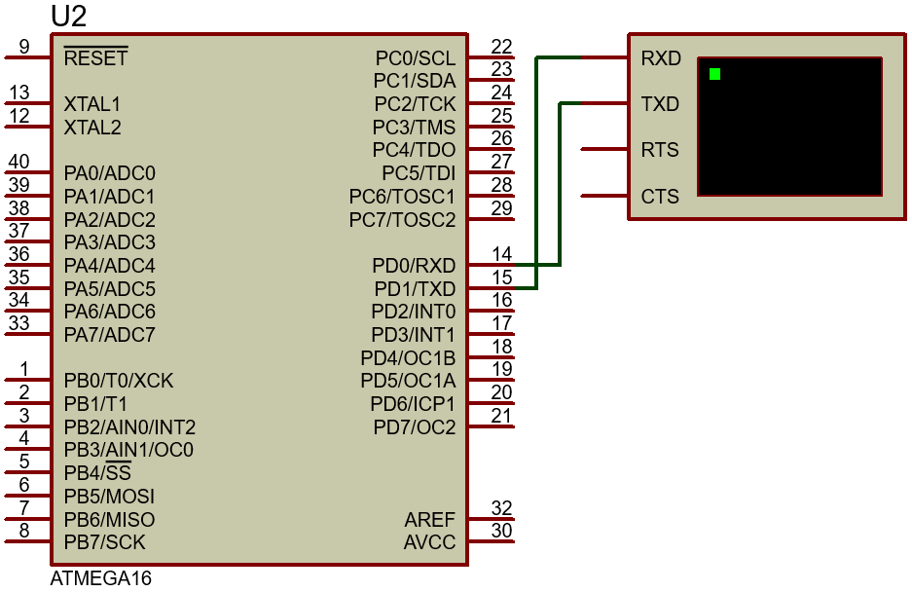

**Virtual Terminal**

**Simulation**

## 3.4:

**#define *F_CPU* 1000000**

**#include <avr/io.h>**

**#include <util/delay.h>**

**//function to initialize UART communication**

**void UART_initializer(){**

**UBRRL = 0x0C ; //set baud rate to 4800**

**UCSRB |= (1<<RXEN) ; //enable transmitter**

**UCSRC |= (1<<URSEL)|(1<<UCSZ0)|(1<<UCSZ1); //set data size**

**}**

**//function to receive data over UART**

**void UART_receive(){**

**while(!(UCSRA & (1<<RXC))); //Poll RXC and wait to receive data**

**char val = UDR;**

**if(val >= '0' && val < '8'){**

**PORTB = 1 << ( val - '0') ;**

**}**

**}**

**int main (void){**

**DDRB = 0xFF;**

**PORTB = 0xFF;**

**UART_initializer(); //initialize UART**

**while(1){**

**UART_receive(); //receive data**

**}**

**}**



**Virtual Terminal**

**Simulation**

## Task B

Connect a 7-segment-display with your ATmega16. Estabilish connection between your ATmega16 and PC through UART-to-TTL converter. Write a program in C such that;

* Initially, ZERO should be displayed on the 7-segment and the program should wait for the next instruction from PC.
* If a ‘u’ is sent from PC to ATmega16, the next digit on seven segment should be displayed in ascending order.

*Ascending order (0,1,2,3,...,8,9,0,1,...)*

* If a ‘d’ is sent from PC to ATmega16, the next digit on seven segment should be displayed in descending order.

*Descending order (9,8,7,...,2,1,0,9,...)*

* If any character other than ‘u’ or ‘d’ is sent, do nothing with 7-segment-display and send “ERR” back to PC in order to notify error.

**Implement the above functionality using AVR SERIAL INTERRUPTS.**

**/\***

**\* Lab8.c**

**\***

**\* Created: 04/04/2022 5:46:06 pm**

**\* Author : Danial and Umer**

**\*/**

**#define *F_CPU* 1000000**

**#include <avr/io.h>**

**#include <util/delay.h>**

**#include <avr/interrupt.h>**

**char counter = 0;**

**char val;**

**char back;**

**char SevenSegment(char counter);**

**void UART_initializer()**

**{**

**UBRRL = 0xC;**

**UCSRB |= (1<<RXEN)|(1<<TXEN)|(1<<TXCIE)|(1<<RXCIE);**

**UCSRC |= (1 << URSEL) | (1 << UCSZ0) | (1 << UCSZ1);**

**}**

**ISR(USART_RXC_vect)**

**{**

**while (!(UCSRA & (1<<UDRE)));**

**char val = UDR;**

**if (val == 'u')**

**{**

**counter += 1;**

**if (counter == 10)**

**{**

**counter = 0;**

**}**

**PORTB = SevenSegment(counter);**

**}**

**else if (val == 'd')**

**{**

**if (counter == 0)**

**{**

**counter = 10;**

**}**

**counter -= 1;**

**PORTB = SevenSegment(counter);**

**}**

**else**

**{**

**UCSRB |= (1<<UDRIE)|(1<<RXEN)|(1<<TXEN)|(1<<TXCIE)|(1<<RXCIE);**

**}**

**}**

**ISR(USART_UDRE_vect){**

**char Error[] = {'\r' , 'E' , 'R' , 'R'};**

**char size_charArray = sizeof(Error) ;**

**unsigned char i ;**

**for ( i = 0; i < size_charArray; i=i+1)**

**{**

**while (!( UCSRA & (1<<UDRE)));**

**UDR = Error[i];**

**}**

**UCSRB &= !(1<<UDRIE);**

**UCSRB |= (1<<RXEN) | (1<<RXCIE);**

**}**

**int main (void)**

**{**

**DDRB = 0xFF;**

**PORTB = SevenSegment(counter);**

**UART_initializer();**

**sei();**

**while (1);**

**}**

**// ------- BCD - 7 Segment Decoder -------**

**char SevenSegment(char number)**

**{**

**if (number == 0) return 0x01;**

**else if (number == 1) return 0x4F;**

**else if (number == 2) return 0x12;**

**else if (number == 3) return 0x06;**

**else if (number == 4) return 0x4C;**

**else if (number == 5) return 0x24;**

**else if (number == 6) return 0x20;**

**else if (number == 7) return 0x0F;**

**else if (number == 8) return 0x00;**

**else if (number == 9) return 0x0C;**

**else return 0xFF;**

**}**



**Simulation**

## Hardware Demonstration



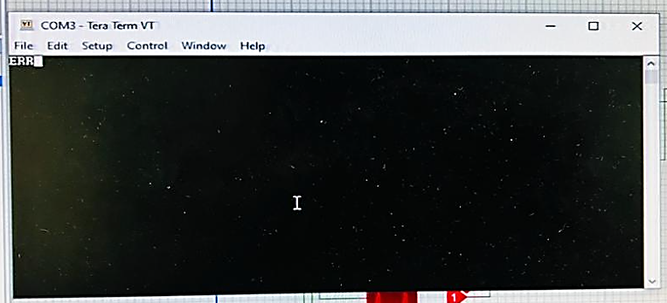

## Conclusion

After the conduction of this lab, we have learnt how to utilize and setup our AVR Microcontroller to accommodate serial communication with a PC to implement simple receiving and transmission tasks. We also utilized serial interrupts to accommodate *full duplex transmission of data*, i.e. data that can both be transmitted and received over a single channel, in making of an up-down counter that counts up only on **‘u’** pressed on keyboard, and down when **‘d’** is pressed. Any other key pressed result in no effect on our counter and transmits **‘ERR’** to the PC.